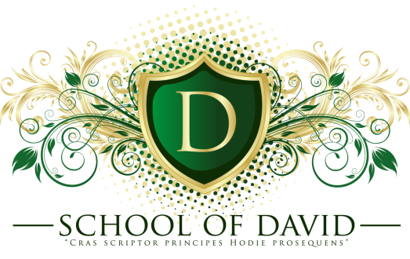

2021 Winter/Spring Sessions
Information

The 2021 Winter/Spring Sessions will be a hybrid classroom consisting of 11 courses to be completed in six (6) months. For each course the student will participate one Saturday per month and will be required to attend the course (Virtually or In-Person) and complete ALL necessary work to earn full credit for certification. Certifications will be given at the 2021 NC COGOP State Conference held in July 2021.

Cost of the Program are listed on the Student Application Forms.

Students can only miss one (1) course without being withdrawn from the school session. All tuition, payments, Pastor’s Endorsements and pre-registration forms must be completed before the deadline in order to participate. Courses for the 2021 Winter/Spring Sessions are included in the Student Application Form and listed below.

If more information is desired, please feel free to contact us and we will be glad to assist you with any matters.

Application Deadline: January 1, 2021

MONTH COURSE
January 16, 2021 Orientation & Breaking Intimidation

February 20, 2021 Bait of Satan
Project – Details In Class

March 20, 2021 Intro. to Counseling & Becoming Emotionally
Healed
April 17, 2021 Pentecostal Heritage & Encountering The Holy
Spirit
Paper (Spiritual Heritage)

May 15, 2021 Dynamics of Effective Communication &
Methods of Preaching

June 19, 2021 Leaders Under Construction & Anointed To
Reign
Paper (Topic To Be Given In Class)

Leadership Development Contact Person(s):
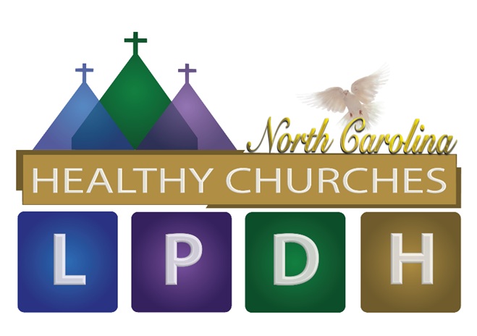
Bishop Dr. Kenny & Melissa Lee
Phone: 336-454-4118 or 919-760-7409
Email: pastorkennylee@gmail.com or melissallee71@gmail.com

